GRAMMAR AND VOCABULARY TEST

Elementary Level

(Present Simple / Present Continuous Tenses, Clothes/My Day Vocabulary)

- Choose the correct answer:

1.Look at him! He …..in a boat. 5. He ….up early every day
a) rows b) rowing c) is rowing a)wake b)is waking c)wakes

2.He usually …..tennis in the afternoon. 6. Be quiet! The baby…………..
a) plays b) play c) is playing a) sleep b)sleeps c)is sleeping

3.What ….in the kitchen, Mum? 7. I… have a shower in the morning
a)do you b)are you doing c)you do a) not b)doesn’t c)don’t

4.She …...breakfast now. 8. Look! The dog …. with the cat.
a)is having b)have c)has a)play b)is playing c)are playing

- Put the verbs into the Present Simple or Present Continuous:

  - He always ……………………(meet) his friends at weekend.
  - They …………………………(watch) TV at the moment.
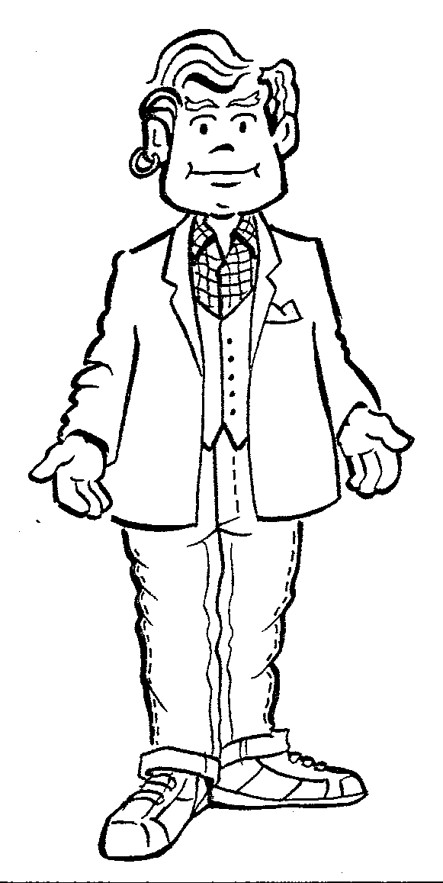
  - John is outside. He …………..(wash) the car.
  - Nina usually …………………(have) a rest after school.
  - Father ………………………..(repair) our old car now.
  - I ……………………………...(not/like) looking after my small sister.

- Answer the questions:

- What clothes is the man wearing in the picture?
- What do you always wear at school?
What do you never wear at home?
What are you wearing now?

- Complete the text with the words:
put on - wash - home – lessons – study – clean – walk - homework have breakfast – at – bed - get up - make

I usually 1)…up at 7 o’clock. I 2)…the bed, 3)…my school clothes and I go to the bathroom where I 4)…my teeth and 5)…my face. After that I always 6)… . I like tea with milk and a sandwich. I leave 7)… at half past seven. I don’t live far from school. I usually arrive at school 8)…twenty to eight. Every day I usually have five or six 9)….At school I 10)…and go home. After school I do my11)… and then I go for a 12)… with my friends. I always go to 13)…at 10 o’clock.

